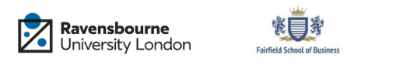

**Student Name: Edlira Taipi**

**Student Number: F2411085**

**Student ID:24025443**

**Unit Title: Digital Consumer Journey (Consumer Behavior)**

**Unit Code: DGM22708**

# Table of Contents

Table of Contents 2

REPORT 5

1. Introduction 5

2. Situation Analysis 6

SWOT analysis 6

Porter’s Five Forces 6

PESTLE Analysis 8

5Cs Analysis 9

3. Customer Journey Mapping 10

4. Consumer Behaviour Analysis 15

STP analysis 15

Influence of Internal factors 17

Influence of External Factors 17

5. Strategic Recommendations 17

6. Conclusion 18

References 19

PRESENTATION 26

Slide 1 – Title Slide 27

Slide 2 – Introduction to the Brand 27

Slide 3 – Defining key concepts 28

Slide 4 – Introduction to your research 28

Slide 5 – Customer Profile 29

Slide 6 – Visual presentation of the brand’s consumer journey 29

Slide 7 – Recommendations, including touchpoints and marketing strategies. 31

Slide 8 – Conclusion 31

Slide 9 - Reference List 32

Appendix 33

**Executive summary**

This report highlights the internal and external environment analysis of Marks & Spencer (M&S) followed by the customer journey and behavioural analysis. The organisation is identified to have a high brand awareness and customer engagement however weak business expansion. Moreover, the greenwashing accoutrements of the organisation can be a threat for the sustainability of the organisation. The business currently target the younger generations however have a strong customer base from the older generations in the UK. The organisation has been recommended to improve focus on reducing greenwashing practices and enhance personalised marketing to attract younger customers towards the brand.

# REPORT

## 1. Introduction

**Marks & Spencer (M&S)** is the chosen organisation from the UK fashion retail sector which implements an Omnichannel marketing strategy to reach a larger audience. The organisation currently has 254 clothing stores in the UK are all acting as micro-fulfilment centres, as well as collectively they are picking around 44% of its customers’ online orders (Marks and Spencer, 2024). The organisation mainly attracts younger customers with their trendy clothing varieties and affordable options. As per the recent data, M&S serves around 30 million customers every year with around 65000 employees across its stores, support centres, warehouse and supply chain (Marks and Spencer, 2025a).

Understanding consumer behaviour plays an important role in the fashion retail sector as it allows them to tailor their products, marketing and overall customer experience to meet evolving demands and build lasting relationships (Grewal and Roggeveen, 2020). In the case of M&S, customers are generally family-focused, work hard, active and are honest, responsible and style-conscious. They mainly demand a personalised, convenient and unified shopping experience across both offline and online channels (Research-live, 2023). This understanding helps them acquire a customer satisfaction score of 77% (Leonards, 2023). This is helping them grow their business in the highly competitive fashion retail market.

This report will include a comprehensive situational analysis of M&S and the UK fashion retail sector, and the customer journey mapping, along with real-world customer behaviour analysis. This will further include strategic recommendations for M&S to improve their customer engagement. Based on theoretical concepts, the digital customer journey of the organisation will be assessed.

## 2. Situation Analysis

### SWOT analysis

|  |  |
| --- | --- |
| **Strengths** | **Weaknesses** |
| * Operating in 46  Countries (BBC, 2021). * Strong brand awareness of 92% in the UK (Statista, 2025a). * 77% customer satisfaction rate (Leonards, 2023). | * The traditional customer base above 45 years may feel neglected (Russon, 2020). * Exiting several international markets due to strategic weakness (SCMP, 2018). |
| **Opportunities** | **Threats** |
| * M&S reduced stock levels to improve stock flow and management (Marks and Spencer, 2025b). | * A tough competition with H&M, Zara and Topshop (Li *et al.* 2023). * 88% of the sustainability claims of M&S would not meet the CAM guideline, showing greenwashing practices (Greenwashing Index, 2025). |

**Table 1: Microenvironment Analysis**

(Source: Self-developed)

### Porter’s Five Forces

|  |  |  |
| --- | --- | --- |
| **Macro Environment Factors** | **Description** | **Impact on M&S** |
| **Customer Power** | M&S serves more than 30 million customers each year through its 1487 stores and 98 websites globally (Globaldata, 2022). | High |
| **Supplier Power** | M&S has 205 suppliers in China, 88 in India, 72in Bangladesh and 54 in Turkey (Statista, 2024).  https://lh7-rt.googleusercontent.com/docsz/AD_4nXeOk9RcenvEBw1bOcvibsnecpo1KM5w-G9W9Uvn_Yeua1VhQJ-Q5DkFx7jNKZNfcyv-9g8-RfmLxqsV0lqbDCrthQ63Y_fL93_8EOEJUk0LN6S0kvwKhYbN5rlY97FdAbfRmvj4yw?key=Jr_3qKUMB1ZhuNMxF4tMjOvV  **Figure 1:  Number of Suppliers from Different countries**  (Source: Statista, 2024) | Moderate |
| **Industry Rivalry** | The company is facing tough competition from online retailers such as Amazon and the luxury fashion brands such as H&M and Zara (Ramirez, 2024). |  |
| **Threats of New Entrants** | New fashion retail brands including Crew Clothing, Albaray and Threats, are facing tough competition from the existing companies (Steelyproducts, 2025; Retail Tech Innovation Hub, 2023; The Creative Industries, 2021). | Moderate to High |
| **Threats of Substitution** | Sustainable fashion brands such as Nobody’s Child, BEEN London, and Mother of Pearl are raising awareness among customers on sustainable and ethically made fashion products (Phatak, 2025). | High |

**Table 2: Macro Environment Analysis**

(Source: Self-developed)

### PESTLE Analysis

|  |  |  |
| --- | --- | --- |
| **Factors** | **Description** | **Impact** |
| Political | The political stability index score in the UK is 0.51 in 2023, which declined from 0.53 in 2022 (The Global Economy, 2024). | Positive |
| Economic | The UK apparel market is projected to see an annual growth rate of 3.39% from 2025-2025 and expected amount of revenue in 2025 is $88.86 billion (Statista, 2025b). | Positive |
| Social | 47% of  women and 53% of men in the UK purchase from sustainable fashion brands (Aovup, 2024). | Positive |
| Technological | Artificial intelligence and e and virtual technologies are used in personalised marketing of products in the UK fashion retail market (Nam and Kannan, 2020). | Positive |
| Environmental | The UK fashion retail market is significantly practising greenwashing, which is affecting brand image (Singh, 2025). | Negative |
| Legal | The “Green Claim Code” and “Consumer Protection Regulations” are protecting consumers from misleading environmental claims (Rebora, 2024). | Positive |

**Table 3: External Environment Analysis**

(Source: Self-developed)

### 5Cs Analysis

|  |  |
| --- | --- |
| Company | M&S is a leading fashion retail chain in the UK, which leverages the Flooid unified commerce basket services platform by enabling the retailer to build omnichannel experiences in-house or with other partners (Berthiaume, 2023). The organisation reported a global revenue growth of around 9.4% in 2023, which is driven by strong sales in the UK (The Guardian, 2024). |
| Collaborators | M&S has developed a partnership with several fashion brands to expand its offerings, which is known as “Brands at M&S”. This includes brands like Superdry, Musto, Lyle & Scott and Ted Baker (Fibre2fashion, 2022). Apart from these, Tommy Hilfiger and Calvin Klein have also joined the platform. |
| Customers | The organisation mainly targets customers within the age range of 18 to 24 years (Radcliffe, 2024). Apart from these, they have a wide range of customer segmentation. The brand often targets the ABC1 socio-economic group, which represents higher earners and those with more disposable income (Arachchi, 2025). |
| Competitors | In the online fashion retail platform, M&S has several competitors such as ASOS, Boohoo, Next Plc which are providing direct competition to the brand (Globaldata, 2024). The fast-moving retailers are providing tough competition to the brand. |
| Context | The demand for personalised fashion products in the UK is significantly increasing. Apart from these the demand for online fashion shopping is also increasing in the UK. In 2023, the online fashion products sales increased by around 31% compared to the overall retail sector (Springfair, 2024). This is leading M&S towards increased focus on omnichannel marketing. |

**Table 4: Internal Analysis**

(Source: Self-developed)

## 3. Customer Journey Mapping

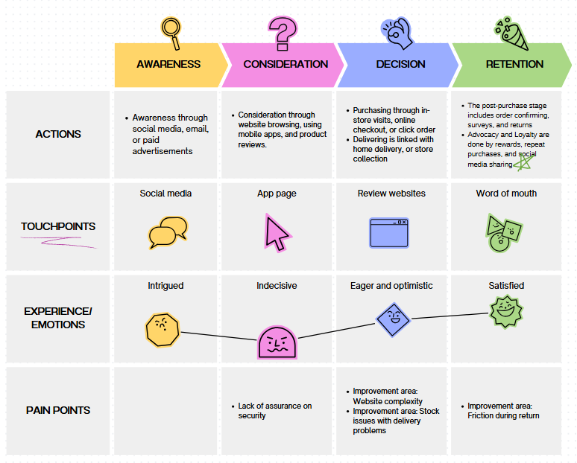

**Figure 1: Customer journey map**

(Source: Self-developed)

While considering the customer journey map, it is seen that the touchpoints constitute the social media, M&S app page, review websites, and word-of-mouth. Social media is a touchpoint that helps in spreading awareness about product, and services. It makes the customers intrigued to observe its product collection, which is associated with emotional responses. On the other hand, M&S app page helps in considering how far the customers’ purchase decisions are influenced, which is understood from the traffic in the page. However, it also makes the customers indecisive as observed from the map. The review websites help in understanding how decisions are made by the customers creating eagerness, and optimism, and also, the word-of-mouth helps in retention of customers, and increases loyalty, which induces satisfaction for customers (Nugraha, Mulyadi and Suriani, 2024).

The AIDA model is used to integrate customer responsiveness at M&S, which is given below:-

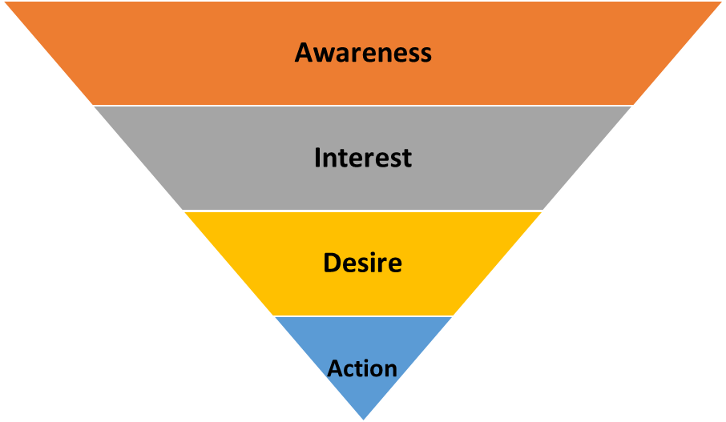

**Figure 2: AIDA Model**

(Source: Self-Developed)

M&S properly uses the AIDA model for its marketing with focus on attention capture, which creates interest by means of branding reputation, and quality, which creates desire from exclusive collaboration, and premium offerings. It also helps in creation of prompt action through different kinds of promotions, as well as sales channels.

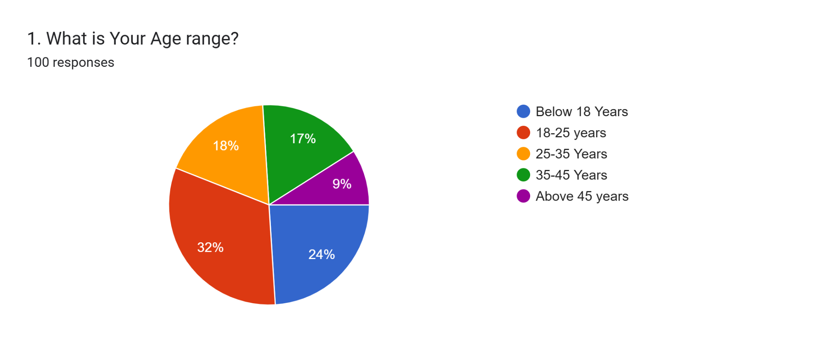

**Figure 3: Response 1**

(Source: Self-developed)

Among the respondents, around 32% are 18-25 years of age, 18% belong to the age range 25-35 years old and 17% belong to the age range 35-45 years. As per the recent data, the share of customers of M&S is growing more proportionately among those under 35 years (Taylor, 2025). Therefore, these responses can be fruitful to assess the customer journey in M&S.

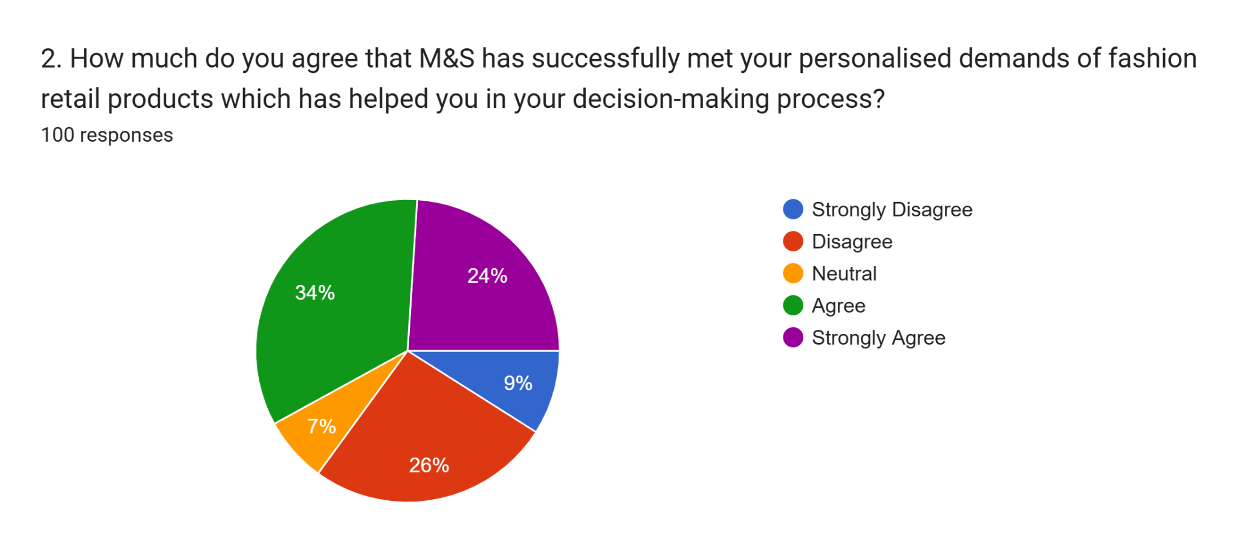

**Figure 4: Response 2**

(Source: Self-developed)

Around 24% and 34% of the participants agreed and strongly agreed with the statement that M&S meets their personalised demands of fashion retail products. However, 26% have disagreed with this statement, depicting that the organisation. In 2022, M&S acquired personalised fashion marketplace Thread, and they anticipated that personalisation would generate 100 million GBP of annual revenue (Leonards, 2022).

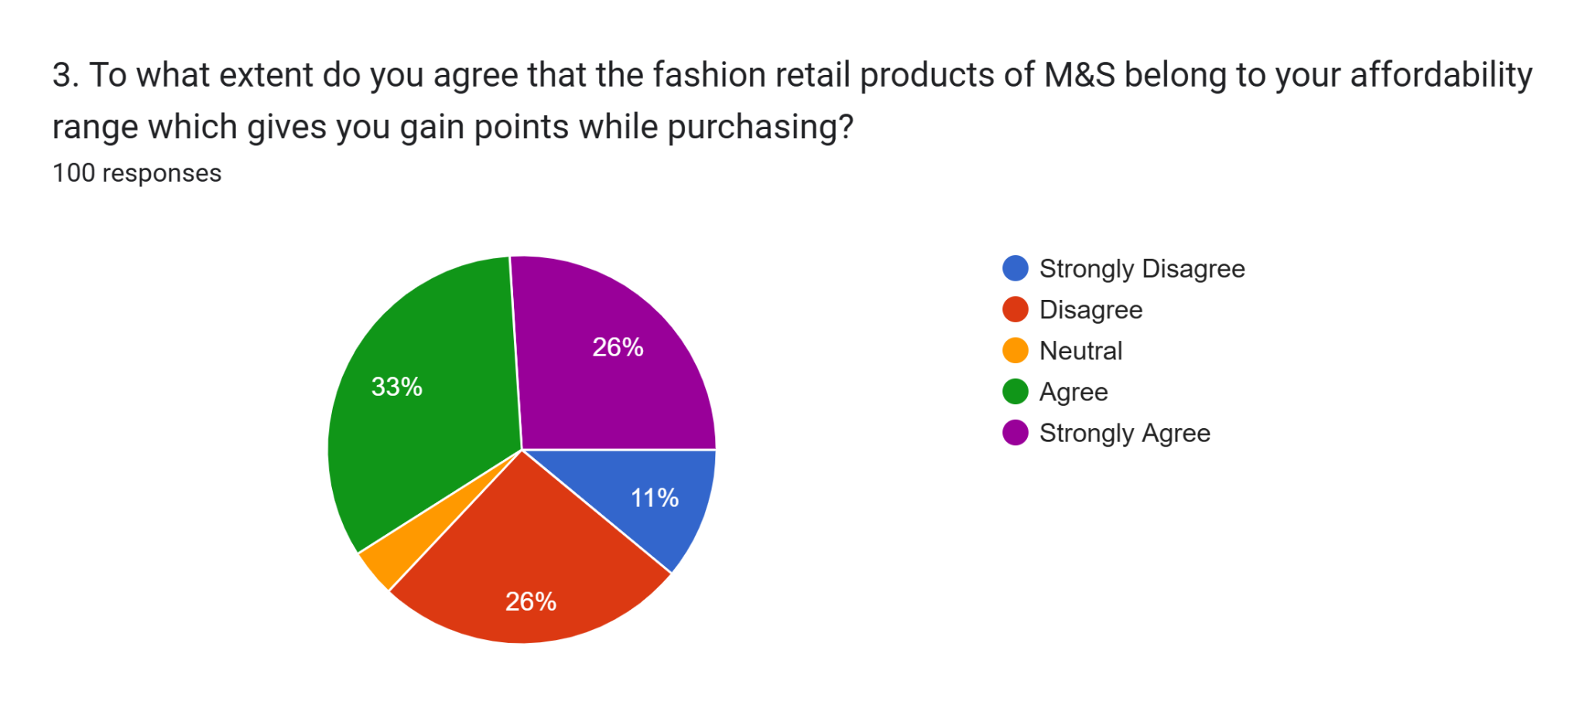

**Figure 5:  Response 3**

(Source: Self-developed)

Around 33% of the participants agreed that the M&S fashion retail products are within their affordability range, and 26% have strongly agreed with this statement. However, 26% of the participants disagreed with this statement. It has been found that M&S implements premium pricing strategy and they continue to invest in brand-building advertising (Marketingsociety, 2025).

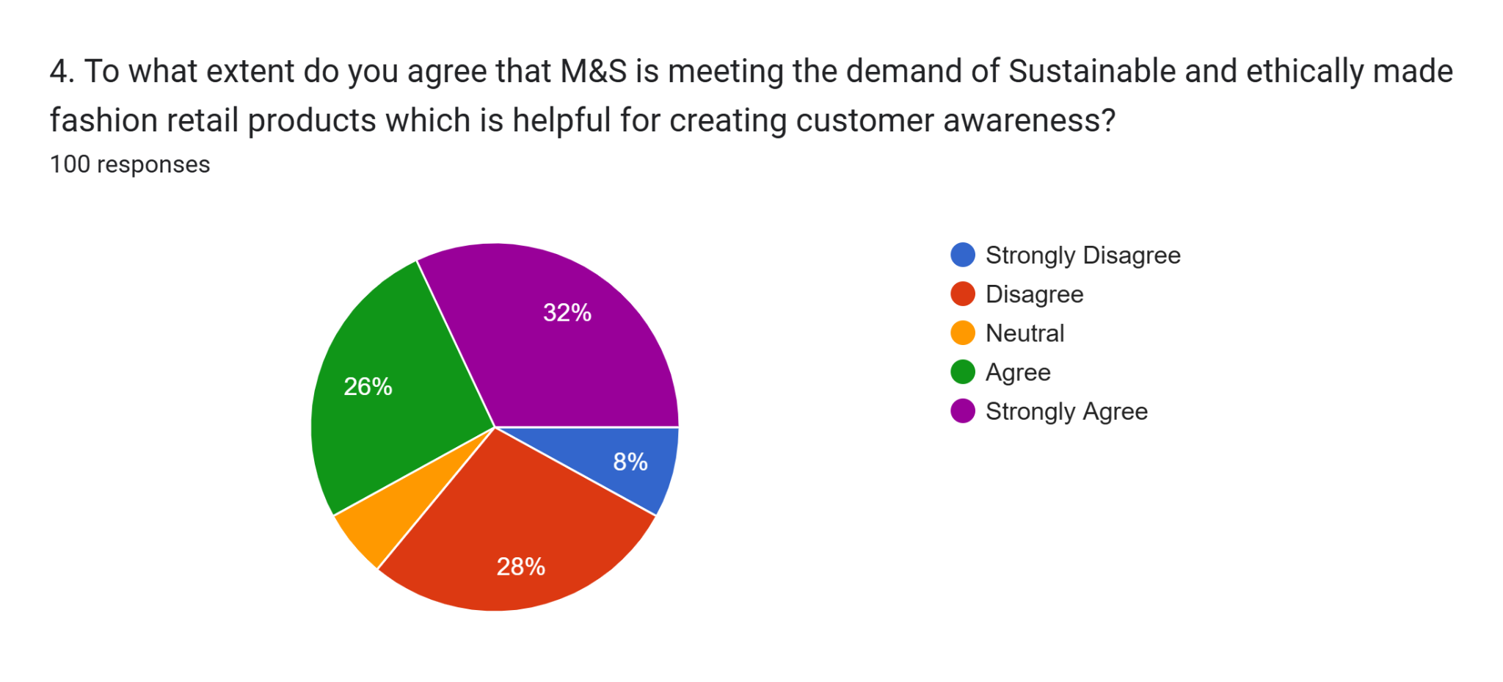

**Figure 6: Response 4**

(Source: Self-developed)

Among 100 respondents, 26% disagreed that M&S does not meet the demand for sustainably and ethically made products in the fashion retail market, which is supporting the greenwashing issues and the decline of brand image due to it in the highly competitive fashion retail market in the UK.

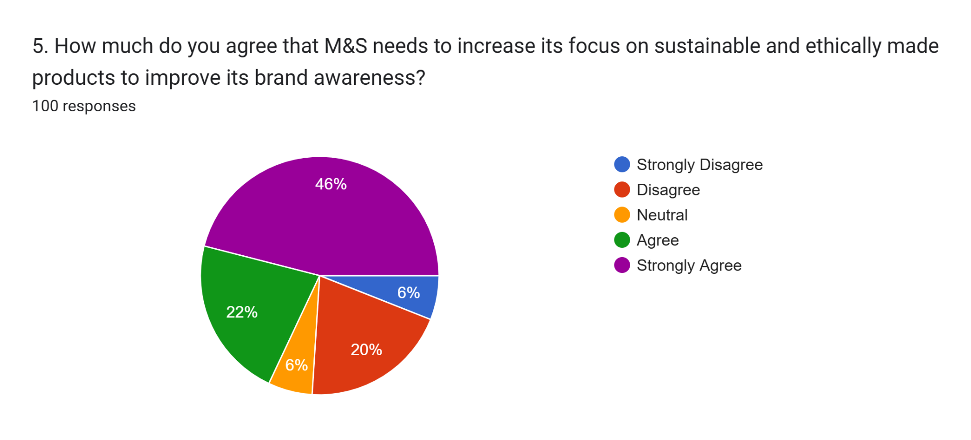

**Figure 7: Response 5**

(Source: Self-developed)

Around 46% of the respondents have strongly agreed with the statement that M&S needs to focus on sustainably and ethically made products to meet the increasing demand for sustainable fashion retail products.

According to Okeke *et al.* (2024), the Customer decision journey is a framework that maps the path a customer takes from initial awareness of products and services to becoming a loyal advocate of the product. This is a process of understanding how customers make purchasing decisions and how businesses can influence those decisions. In the case of the fashion retail industry, the customers are significantly influenced by the personalisation of products in the digital era where the organisations are becoming more aware of the individual needs of the customers (Saura *et al*. 2020). From the survey responses of the M&S customers, it can be clearly depicted that the organisation is moderately focusing on the personalisation of their fashion retail products and they are not at all satisfied with the sustainability practices of the brand which is depicting that the organisation has to focus on the sustainability practise to attract the wider customer range. Apart from these, the affordability of the products is also affecting the customers' purchase decisions. From the perspective of an organisation, Kumar (2023) stated that the AIDA model stands for Attention, interest, desire and action of an organisation that outlines a series of stages that a communication message should ideally go through to persuade as well as influence audiences. M&S is actively working to reinvigorate its style perception and engage customers in new ways three years into its brand transformation program (Rashbass, 2024).

## 4. Consumer Behaviour Analysis

### STP analysis

|  |  |
| --- | --- |
| **Segmentations** | Demographic: Traditionally 35-65 years of and expanding to 25-34 with trendier collections, both male and female and the middle to upper-income group.  Psychographic: Customers who are quality conscious and loyal to the brand and value ethical consumption  Behavioural: Customers who seek for reputable brand for seasonal clothing and prefer to purchase products via online platforms.  Geographic: the UK and internationally in Europe and Asian countries (Statista, 2025c; Textile Excellence, 2016). |
| **Target Customers** | Recently, M&S has been making efforts to attract younger customers, especially millennials and Gen Z especially who belong to the upper income range. Millennials make more than 54% of their total purchases online and 67% shop from physical stores (Etaileurope, 2025). |
| **Value Positioning** | https://lh7-rt.googleusercontent.com/docsz/AD_4nXcQkZD3-KHTm964nm8jlE2xTvugKzRT3lA4VzJ9klJUFkwp0oS3yKauKdIt6AaddS9aypEf7_QyBET-e7wPO3iNIiJY0xXRtCRHYDvYaBsqvPsH8gfEL2e2o_U1lNyvh8X7gQgNWQ?key=Jr_3qKUMB1ZhuNMxF4tMjOvV  **Figure 7: Perceptual Mapping**  (Source: Self-developed) |

**Table 5: STP Analysis**

(Source: Self-developed)

### Influence of Internal factors

Some of the internal factors, such as motivation, perception, learning, attitude, personality and lifestyle, along with income, play an important role in making purchase decisions. In the case of M&S, their commitment towards superior quality of clothing combined with sustainability practices motivates customers to purchase their products (Rezaid, 2025). However, greenwashing accusations are affecting their trust. Overall, a significant number of customers (81%) show loyalty towards the brand (Bashir, 2025). The customers of the organisation value quality and sustainability, which influences them to stay engaged with the organisation. The organisation attracts both the aged and the young generation with their traditional and trendy products.

### Influence of External Factors

The external factors include culture, economic environment, technological and situational factors, which significantly impact the purchase behaviour of customers. For example, the cost-of-living crisis in the UK significantly affected the customer purchase decisions as they are reducing spending on non-essential products and seeking cheaper alternatives to become more price conscious (Hodgson, 2023).

## 5. Strategic Recommendations

**Recommendation 1: M&S is recommended to increase its focus and investment in sustainable and ethically-made products and overcome the issues of greenwashing.**

Greenwashing significantly impact the customer trust in an organisation.  As per the recent data, around 57% of Britons see sustainability as important for fashion, whereas around 88% of M&S’s sustainability claims would not meet sustainability guidelines (Mintel, 2024; Greenwashing Index, 2025). Therefore, the organisation needs to increase its focus on sustainability practices and develop a transparent operational structure to attract target customers with long-term engagement.  In order to avoid greenwashing, M&S must focus on specific claims about sustainability, increase transparency in efforts, and avoid vagueness in language. It needs to avoid claims for products without concrete evidence in terms of environmental advantages like recycling of content percentage, or decrease in carbon emission. M&S should also clearly communicate right initiatives for being a part of part in sustainability program.

**Recommendation 2: The organisation is recommended to increase focus on personalisation of their products to attract customers from younger generations.**

M&S uses AI to advise shoppers on their outfit choices based on their body shapes and style preferences; however, the organisation lacks recommendations of products based on the customers’ buying behaviour (Butler, 2024). Therefore, the organisation is needed to increase its focus on the buying patterns of customers based on advanced technologies to improve its competitiveness to attract target customers from the younger generation. Marks & Spencer (M&S) implements AI-based personalisation with leverage of AI algorithms for personalisation of product recommendation, improvement in customer service, and increase loyalty programs (Schweidel *et al*. 2022). For example, it is possible to use AI for doing analysis of customer data from loyalty scheme like Sparks to create tailored experiences, and recommendations in multiple virtual channels.

## 6. Conclusion

As per the above assessment, it can be concluded that M&S significantly implement omnichannel marketing where the physical stores help engage customers from the older generations, and online shopping portals are attracting the younger generation towards the brand. There are several internal factors, such as motivation, lifestyle and values, including the buying behaviour; however, the external factors, such as the cost-of-living crisis, are affecting the customer's buying behaviour significantly.

## References

Aovup, 2024. *Sustainable Fashion Statistics.* Available at: <https://aovup.com/stats/sustainable-fashion/#:~:text=a%20bit%20deeper.-,53%25%20of%20men%20and%2047%25%20of%20women%20in%20the,UK%20buy%20from%20sustainable%20brands.&text=Sustainable%20fashion%20statistics%20for%20the,to%20buy%20from%20sustainable%20brands>. (Accessed: 09 April 2025).

Arachchi, T.K., 2025. *Mapping UK and Sri Lankan Supermarkets to A B C1 C2 D E Social Grades.* Available at: <https://www.linkedin.com/pulse/mapping-uk-sri-lankan-supermarkets-b-c1-c2-d-e-social-terence-esqzc/> (Accessed: 09 April 2025).

Bashir, U., 2025. *M&S brand profile in the UK 2022.* Available at: <https://www.statista.com/forecasts/1335626/mands-fashion-stores-brand-profile-in-the-uk> (Accessed: 11 April 2025).

BBC, 2021. *Mark & Spencer launches online operations in 46 markets.* Available at: <https://www.bbc.com/news/business-56327257> (Accessed: 09 April 2025).

Berthiaume, D., 2023. *Marks & Spencer unifies enterprise omnichannel operations.* Available at: <https://chainstoreage.com/marks-spencer-unifies-enterprise-omnichannel-operations#:~:text=Marks%20%26%20Spencer%20bases%20omnichannel%20experience%20on%20POS%20platform&text=The%20retailer%20leverages%20the%20Flooid,house%20or%20with%20other%20partners>. (Accessed: 09 April 2025).

Butler, S., 2024. *M&S using AI as personal style guru in effort to boost online sales.* Available at: <https://www.theguardian.com/business/article/2024/sep/05/m-and-s-using-ai-to-advise-shoppers-body-shape-style-preferences> (Accessed: 11 April 2025).

Etaileurope, 2025. *How Marks & Spencer Is Using Instagram Strategy to Attract Millennials.* Available at: <https://etaileurope.wbresearch.com/blog/marks-spencer-instagram-photo-search-strategy-attract-younger-audience> (Accessed: 11 April 2025).

Fibre2fashion, 2022. *UK's Marks & Spencer adds 3rd-party brand partners to online platform.*  [Available at: https://www.fibre2fashion.com/news/apparel-announcement-news/uk-s-marks-spencer-adds-3rd-party-brand-partners-to-online-platform-284315-newsdetails.htm#:~:text=UK's%20Marks%20&%20Spencer%20(M&S)%20has%20added,at%20M&S'%20platform%20as%20the%20retailer%20continues](https://www.fibre2fashion.com/news/apparel-announcement-news/uk-s-marks-spencer-adds-3rd-party-brand-partners-to-online-platform-284315-newsdetails.htm#:~:text=UK's%20Marks%20&%20Spencer%20(M&S)%20has%20added,at%20M&S'%20platform%20as%20the%20retailer%20continues) (Accessed: 09 April 2025).

Globaldata, 2022. *Number of Marks and Spencer Group Stores Globally (FY2016 – FY2022).* Available at: <https://www.globaldata.com/data-insights/retail-amp-wholesale/number-of-marks-and-spencer-group-stores-globally/#:~:text=The%20company%20through%20its%20subsidiary,%2C%20warehouses%2C%20and%20supply%20chain>. (Accessed: 09 April 2025).

Globaldata, 2024. *Marks and Spencer Group plc: Competitors.* Available at: <https://www.globaldata.com/company-profile/marks-and-spencer-group-plc/competitors/> (Accessed: 09 April 2025).

Greenwashing Index, 2025. *Is Marks & Spencer Sustainable Or Just Another Fast Fashion Brand?.* Available at: <https://www.greenwashingindex.com/is-marks-spencer-sustainable-or-fast-fashion/#:~:text=M%26S%20Greenwashing&text=Essentially%2C%20Changing%20Markets'%20analysis%20found,there's%20significant%20greenwashing%20going%20on>! (Accessed: 09 April 2025).

Grewal, D. and Roggeveen, A.L. (2020). Understanding Retail Experiences and Customer Journey Management. *Journal of Retailing*, 96(1), pp.3–8.

Hodgson, A., 2023. *Top Consumer Trends and Behaviour Changes Amid the Cost of Living Crisis.* Available at: <https://www.euromonitor.com/article/top-consumer-trends-and-behaviour-changes-amid-the-cost-of-living-crisis#:~:text=Loyalty%20no%20more,Budgeteers%20trend%20in%20full%20force>. (Accessed: 11 April 2025).

Kumar, C., 2023. *The AIDA Model of Communication.* Available at: <https://www.linkedin.com/pulse/aida-model-communication-chandan-kumar/> (Accessed: 09 April 2025).

Leonards, A., 2022. *M&S to 'generate £100m' after takeover of personalised fashion marketplace.* Available at: <https://www.retail-systems.com/rs/Marks_And_Spencer_Buys_Personalised_Fashion_Marketplace.php> (Accessed: 09 April 2025).

Leonards, A., 2023. *Aldi, M&S and Waitrose beat ‘Big Four’ for customer satisfaction.* Available at: <https://www.retail-systems.com/rs/Aldi_M_And_S_And_Waitrose_Beat_Big_Four_For_Customer_Satisfaction.php#:~:text=M%26S%20came%20in%20first%20place,stars%20for%20value%20for%20money>. (Accessed: 09 April 2025).

Li, L., Wang, Y. and Zhang, Y.Y., 2023. A critical examination of M&S's current strategic and marketing position, as well as potential sustainable competitive marketing strategies. *International Journal of Science and Business*, *18*(1), pp.108-117.

Marketingsociety, 2025. *About The Marketing Society.* Available at: <https://marketingsociety.com/sites/default/files/thelibrary/marketing%20excellence%202%20m&s%20(sustaining%20the%20brand%20promise)%20case%20study.pdf> (Accessed: 09 April 2025).

Marks and Spencer, 2024. *Omnichannel Advantage: Stepping up Local Fulfilment This Festive Season Supported by Our 3,000 Support Centre Colleagues.* Available at: <https://corporate.marksandspencer.com/omnichannel-advantage-stepping-local-fulfilment-festive-season-supported-our-3000-support-centre> (Accessed: 09 April 2025).

Marks and Spencer, 2025a. *Welcome to M&S.* Available at: <https://corporate.marksandspencer.com/#:~:text=Welcome%20to%20M%26S&text=Together%20our%2065%2C000%20colleagues%20across,30%20million%20customers%20every%20year>. (Accessed: 09 April 2025).

Marks and Spencer, 2025b. *Reshaping.* Available at: <https://corporate.marksandspencer.com/sites/marksandspencer/files/2024-06/M-and-S-2024-Annual-Report.pdf> (Accessed: 09 April 2025).

Mintel, 2024. *Sustainable Fashion Market Outlook.* Available at: <https://store.mintel.com/report/uk-fashion-sustainability-market-report> (Accessed: 11 April 2025).

Nam, H. and Kannan, P.K. (2020). Digital Environment in Global Markets: Cross-Cultural Implications for Evolving Customer Journeys. *Journal of International Marketing*, 28(1), p.1069031X1989876.

Nugraha, A.P., Mulyadi, M. and Suriani, S. (2024). CUSTOMER JOURNEY MAPPING: UNDERSTANDING CONSUMER BEHAVIOR DIGITALLY. *Berajah Journal*, 4(2), pp.327–336.

Okeke, N.I., Alabi, O.A., Igwe, A.N., Ofodile, O.C. and Ewim, C.P.M., 2024. Customer journey mapping framework for SMEs: Enhancing customer satisfaction and business growth. *World Journal of Advanced Research and Reviews*, *24*(1).

Phatak, A., 2025. *35 Sustainable & Ethical Fashion Brands From The UK In 2025 (Updated List).* Available at: <https://www.gofynd.com/thecloset/sustainable-fashion-brands-uk?srsltid=AfmBOopxhwkVShO9qfCSedLBdggHncjqV_wurYjOKvdWB-zWEYF2oCn9> (Accessed: 09 April 2025).

Radcliffe, E., 2024. *Research: M&S More Popular With Gen Z Than Baby Boomers.*  [Available at: https://saturnvisual.com/research-ms-more-popular-with-gen-z-than-baby-boomers/#:~:text=Research%3A%20M%26S%20More%20Popular%20With%20Gen%20Z%20Than%20Baby%20Boomers&text=Whilst%20popular%20amongst%20all%20of,stores%20they'd%20been%20to](https://saturnvisual.com/research-ms-more-popular-with-gen-z-than-baby-boomers/#:~:text=Research%3A%20M%26S%20More%20Popular%20With%20Gen%20Z%20Than%20Baby%20Boomers&text=Whilst%20popular%20amongst%20all%20of,stores%20they'd%20been%20to). (Accessed: 09 April 2025).

Ramirez, M., 2024. *Marks & Spencer: Business Model, SWOT Analysis, and Competitors 2024.* Available at: <https://pitchgrade.com/companies/marks-and-spencer> (Accessed: 09 April 2025).

Rashbass, H., 2024. *M&S pledges to ‘upgrade digital experience’ to fuel growth.* Available at: <https://www.marketingweek.com/marks-and-spencer-digital-experience/#:~:text=Opting%20for%20a%20marketing%20strategy,app%20experience%20to%20drive%20growth.&text=Marks%20&%20Spencer%20says%20it%20needs,towards%20brand%20and%20social%20channels>. (Accessed: 09 April 2025).

Rebora, M., 2024. *All you need to know about CSR textile legislation in the UK.* Available at: <https://www.traceforgood.com/blog/uks-csr-regulation#:~:text=Restricting%20Greenwashing%3A%20The%20Green%20Claims,about%20their%20products%20or%20services>. (Accessed: 11 April 2025).

Research-live, 2023. *Out of the ordinary: How insight helped M&S define its customer.* Available at: <https://www.research-live.com/article/features/out-of-the-ordinary-how-insight-helped-ms-define-its-customer/id/5107612#:~:text=There%20were%20two%20waves%20of,responsible%2C%20caring%20and%20style%20conscious>. (Accessed: 09 April 2025).

Retail Tech Innovation Hub, 2023. *The UK's most innovative fashion retailers in 2023.* Available at: <https://retailtechinnovationhub.com/home/2023/10/5/the-uks-most-innovative-fashion-retailers-in-2023#:~:text=Conclusion,at%20the%20forefront%20of%20fashion>. (Accessed: 09 April 2025).

Rezaid, 2025. *Marks and Spencer’s Digital Revolution: A Success Story.* Available at: <https://www.rezaid.co.uk/post/marks-and-spencers-digital-revolution-a-success-story#:~:text=Millions%20of%20global%20consumers%20select,along%20with%20customer%20preference%20updates>. (Accessed: 11 April 2025).

Russon, M. A., 2020. *M&S: Five reasons the retailer is struggling.* Available at: <https://www.bbc.com/news/business-53478403> (Accessed: 09 April 2025).

Saura, J.R., Reyes-Menendez, A., Matos, N., Correia, M.B. and Palos-Sanchez, P. (2020). Consumer behavior in the digital age. *Journal of Spatial and Organizational Dynamics*, 8(3), pp.190–196.

Schweidel, D.A., Bart, Y., Inman, J.J., Stephen, A.T., Libai, B., Andrews, M., Rosario, A.B., Chae, I., Chen, Z., Kupor, D., Longoni, C. and Thomaz, F. (2022). How consumer digital signals are reshaping the customer journey. *Journal of the Academy of Marketing Science*, 50(50).

SCMP, 2018. *Marks and Spencer ends mainland online operations in retreat from China.* Available at: <https://www.scmp.com/business/china-business/article/2127967/marks-and-spencer-ends-mainland-online-operations-retreat> (Accessed: 09 April 2025).

Singh, S., 2025. *Greenwashing In The Fashion Industry.* Available at: <https://carbontrail.net/blog/greenwashing-in-the-fashion-industry/#:~:text=Penalties%20For%20Greenwashing%20In%20Fashion&text=In%20the%20UK%2C%20some%20of,exclusively%20those%20in%20conscious%20ranges>. (Accessed: 11 April 2025).

Springfair, 2024. *UK Fashion Industry Recap 2024: Statistics and Trends.* Available at: <https://www.springfair.com/news/uk-fashion-industry-recap-2024-statistics-trends#:~:text=The%20UK%20remains%20Europe's%20leader,shopping%2C%20accelerated%20by%20the%20pandemic>. (Accessed: 09 April 2025).

Statista, 2024. *Number of clothing and home supplier factories of Marks & Spencer as of September 2024, by country.* Available at: <https://www.statista.com/statistics/1102485/number-of-suppliers-of-marks-and-spencer-by-country/>  (Accessed: 09 April 2025).

Statista, 2025a. *Marks & Spencer brand awareness, usage, popularity, loyalty, and buzz among fashion online shop users in the UK in 2024.* Available at: <https://www.statista.com/forecasts/1252284/marks-and-spencer-fashion-online-shops-brand-profile-in-the-uk> (Accessed: 09 April 2025).

Statista, 2025b. *Apparel - United Kingdom.* Available at: <https://www.statista.com/outlook/cmo/apparel/united-kingdom> (Accessed: 09 April 2025).

Statista, 2025c. *Marks and Spencer - statistics & facts.* Available at: <https://www.statista.com/topics/3707/marks-and-spencer/#:~:text=Marks%20and%20Spencer%20(M&S)%20is,of%20the%20company's%20international%20operations>. (Accessed: 11 April 2025).

Steelyproducts, 2025. *Crew Clothing among fastest-growing UK fashion retailers.* Available at: <https://www.steelyproducts.co.uk/blog/crew-clothing-among-fastest-growing-uk-fashion-retailers/#:~:text=The%20report%20looks%20at%20financial,multi%2Dchannel%20approach%20to%20retailing>. (Accessed: 09 April 2025).

Taylor, N., 2025. *Average age of M&S customers drops as its image improves.* Available at: <https://ww.fashionnetwork.com/news/Average-age-of-m-s-customers-drops-as-its-image-improves,1689097.html#:~:text=However%2C%20its%20share%20has%20grown,clothes%20were%20aged%20over%2055>. (Accessed: 09 April 2025).

Textile Excellence, 2016. *M&S To Close All Foreign SM&S To Close All Foreign Stores And 30 Outlets In The UKtores And 30 Outlets In The UK.* Available at: <https://textileexcellence.com/single-news/1673/m-amp-s-to-close-all-foreign-sm-amp-s-to-close-all-foreign-stores-and-30-outlets-in-the-uktores-and-30-outlets-in-the-uk#:~:text=International%20businesses%20that%20are%20fully%20owned%20by,in%20Europe%2C%20Asia%20and%20the%20Middle%20East>. (Accessed: 11 April 2025).

The Creative Industries, 2021. *Fashion: 10 UK companies shaping the future of fashion.* Available at: <https://www.thecreativeindustries.co.uk/site-content/industries-fashion-fashion-10-uk-companies-shaping-the-future-of-fashion#:~:text=1.),Saveyourwardrobe> (Accessed: 09 April 2025).

The Global Economy, 2024. *United Kingdom: Political stability.* Available at: <https://www.theglobaleconomy.com/United-Kingdom/wb_political_stability/> (Accessed: 09 April 2025).

The Guardian, 2024. *Marks & Spencer boss hails ‘growth story’ as annual profits rise 41%.* Available at: <https://www.theguardian.com/business/article/2024/may/22/marks-and-spencer-cost-cuts-profits-rise#:~:text=Sales%20rose%209.4%%20to%20%C2%A313bn%20on%20the,was%20not%20just%20a%20result%20of%20inflation%2C> (Accessed: 09 April 2025).

# PRESENTATION

# Slide 1 – Title Slide

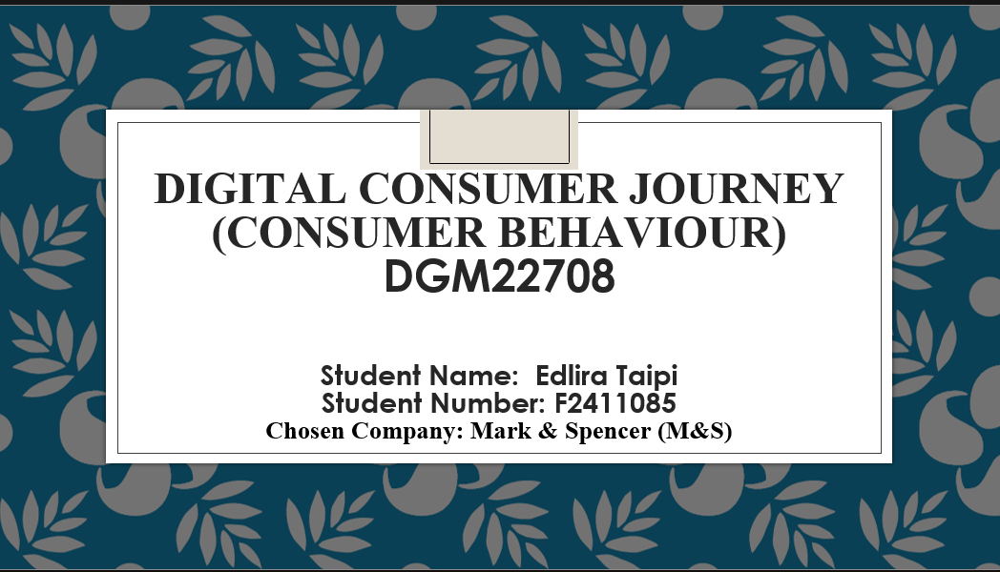

## Slide 2 – Introduction to the Brand

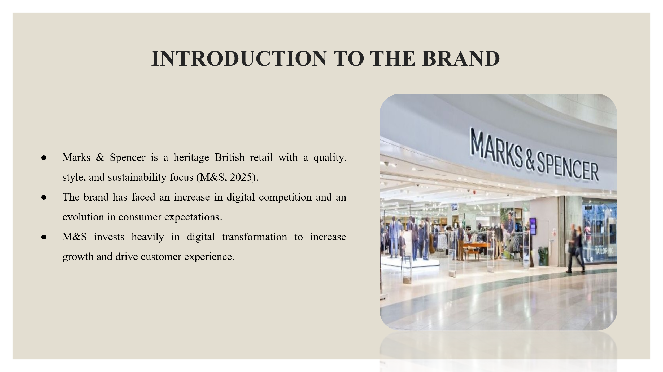

## Slide 3 – Defining key concepts

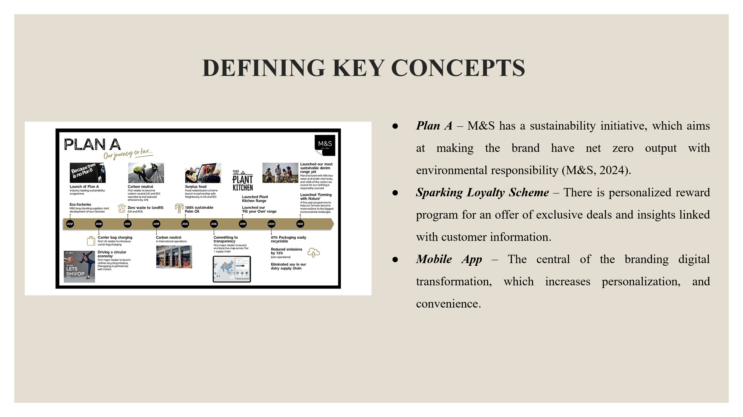

## Slide 4 – Introduction to your research

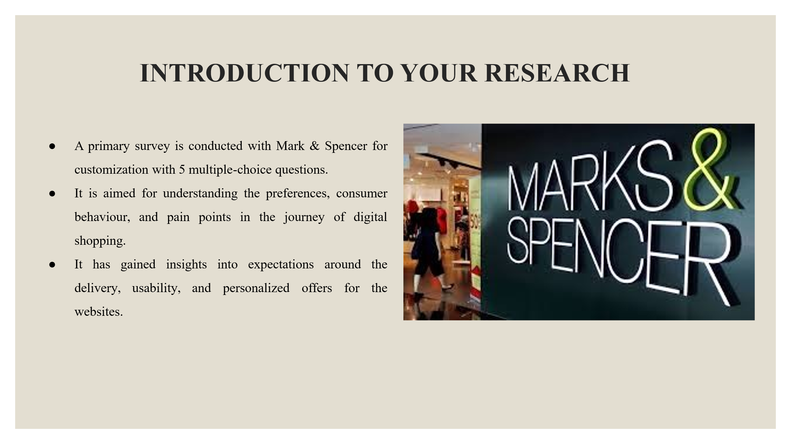

## Slide 5 – Customer Profile

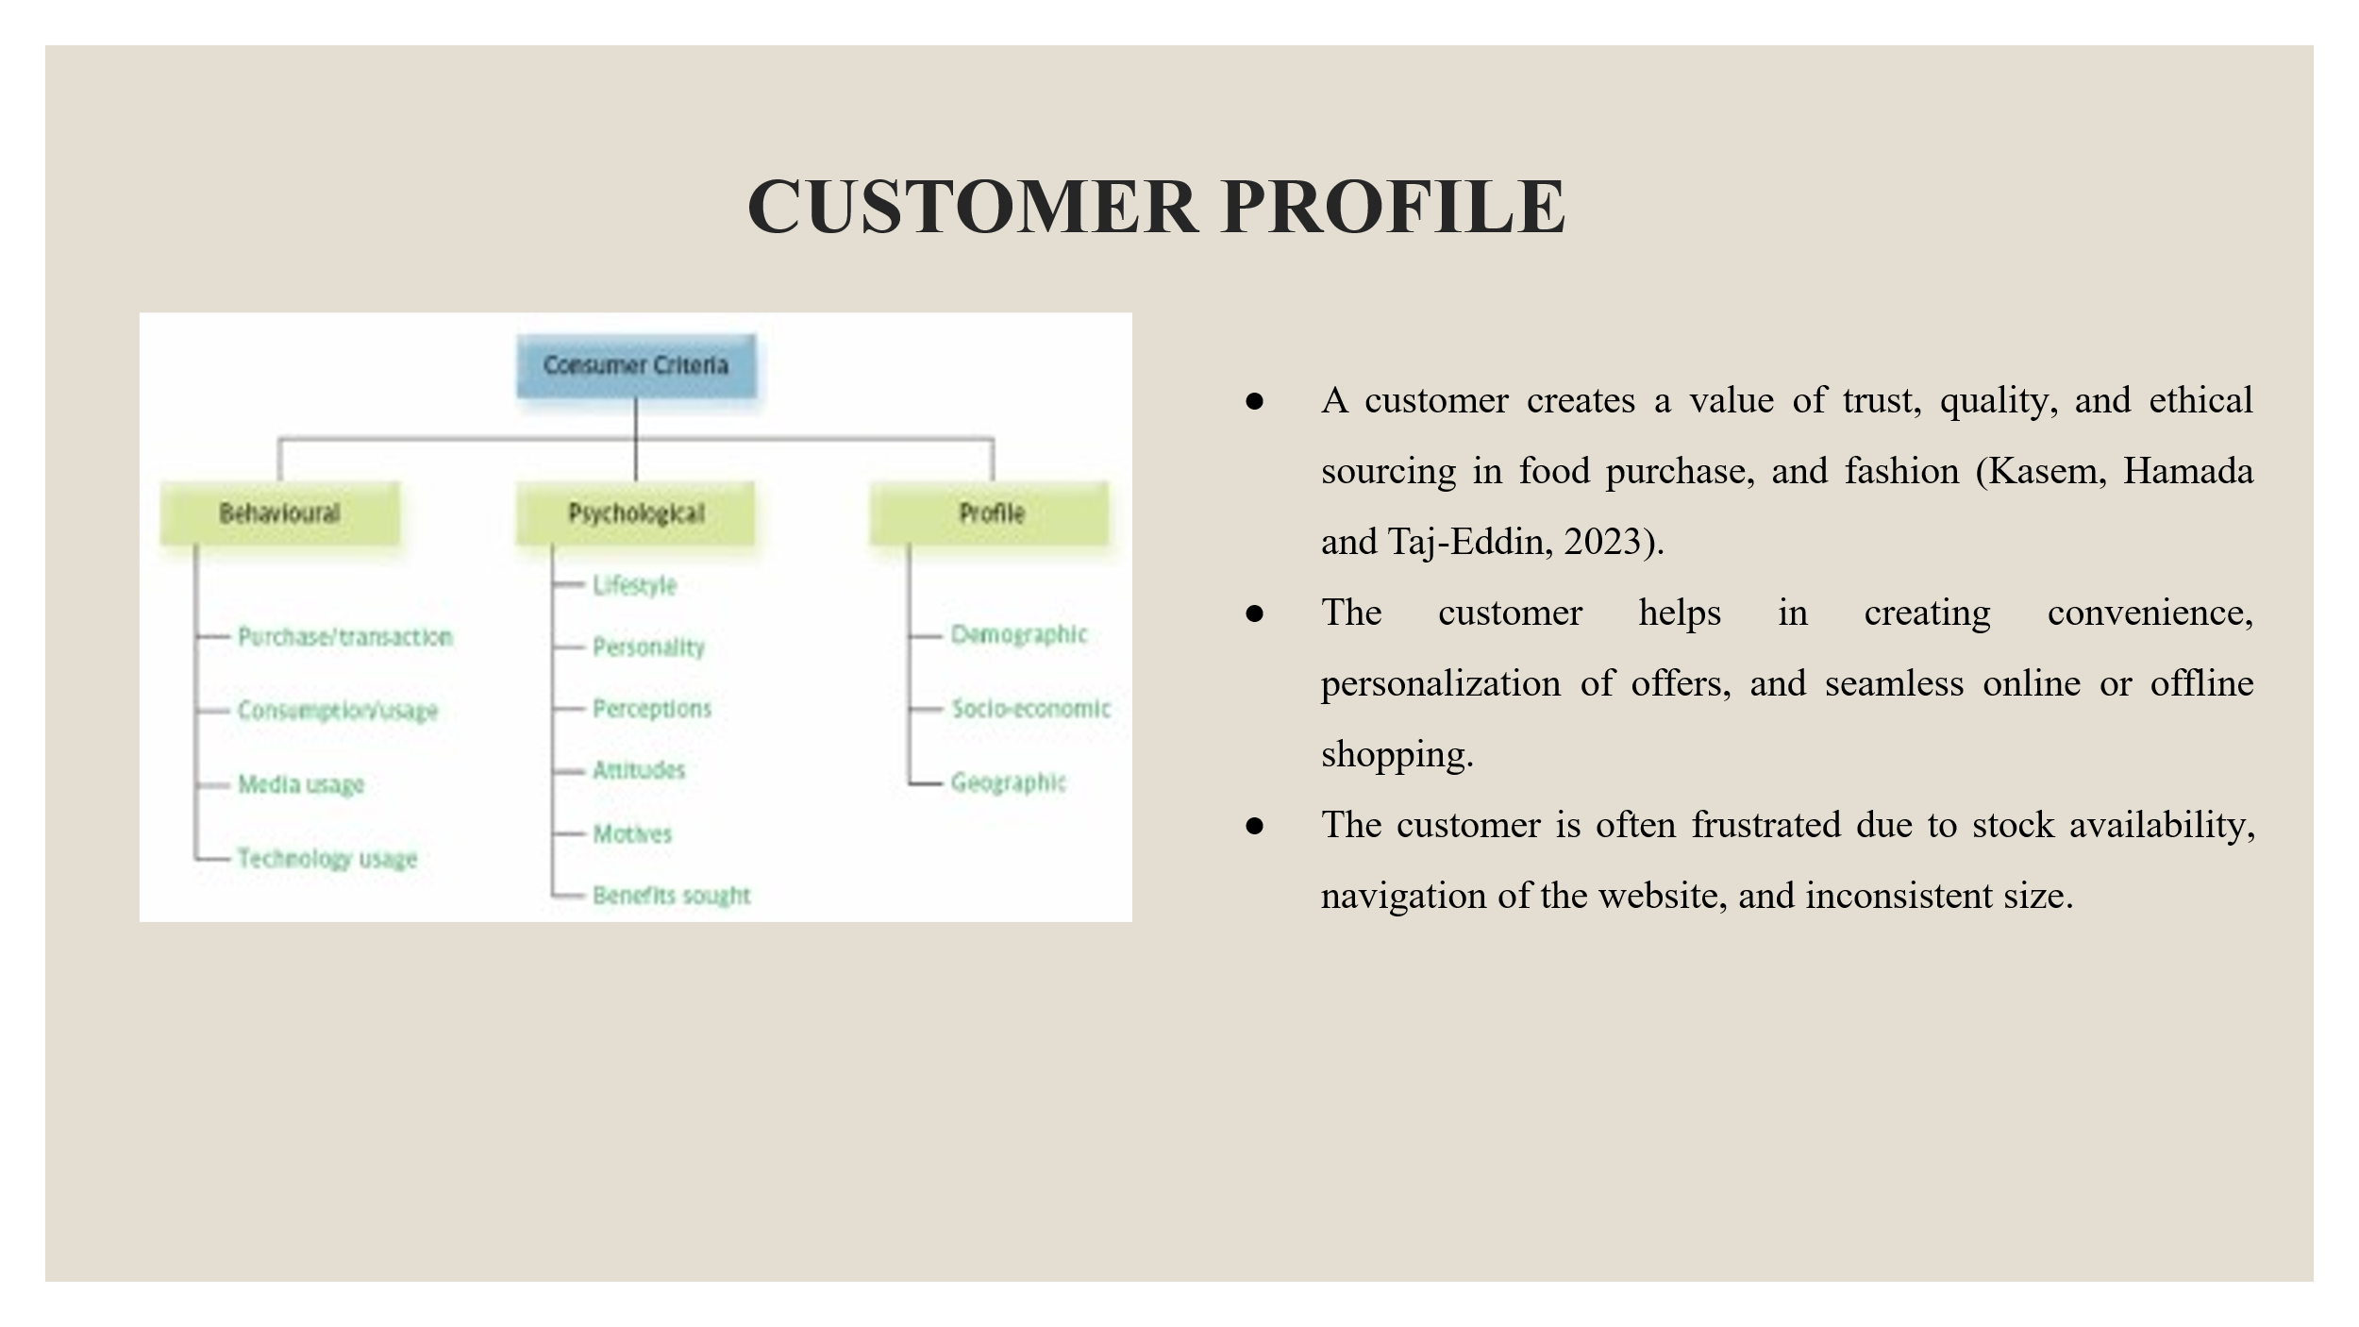

## Slide 6 – Visual presentation of the brand’s consumer journey

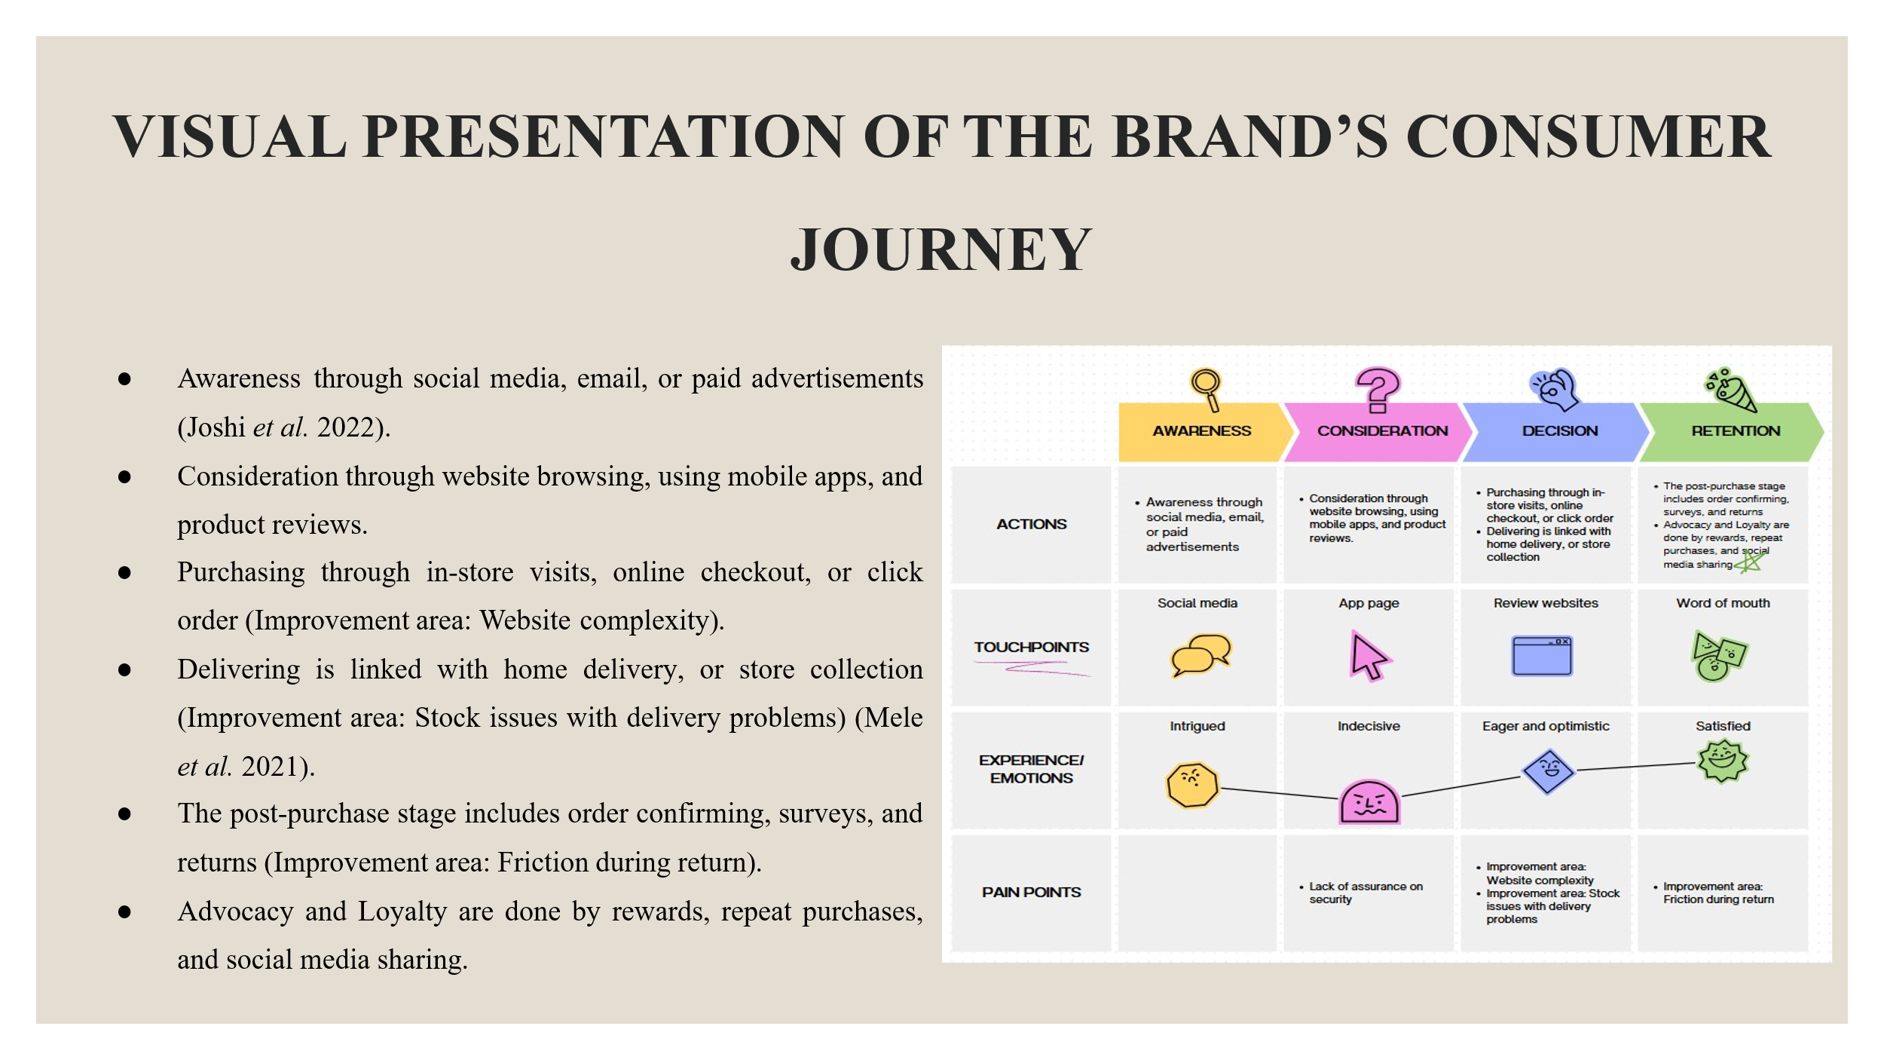



**Figure 1: Customer Journey Map**

(Source: Self-Developed)

## Slide 7 – Recommendations, including touchpoints and marketing strategies.

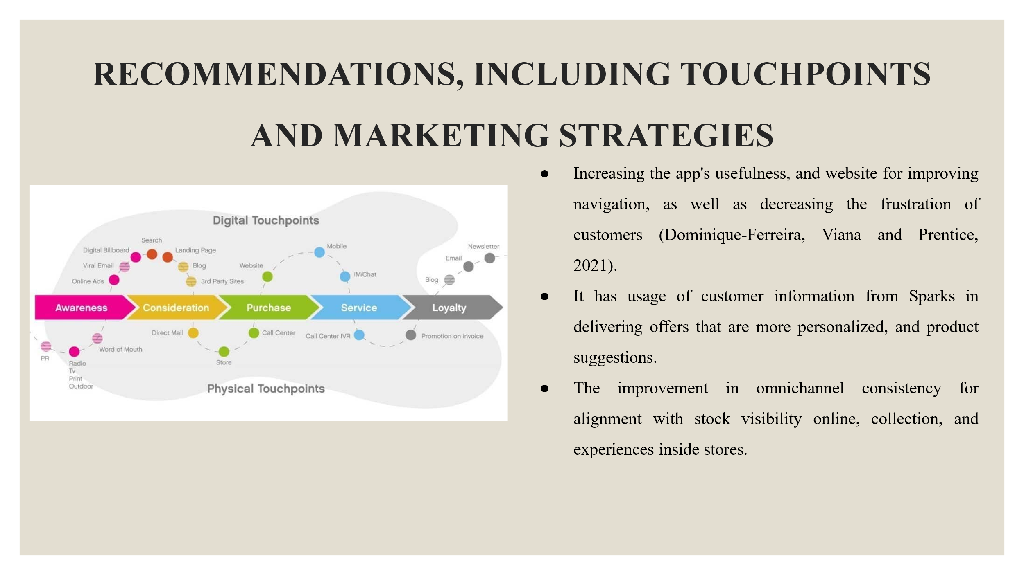

## Slide 8 – Conclusion

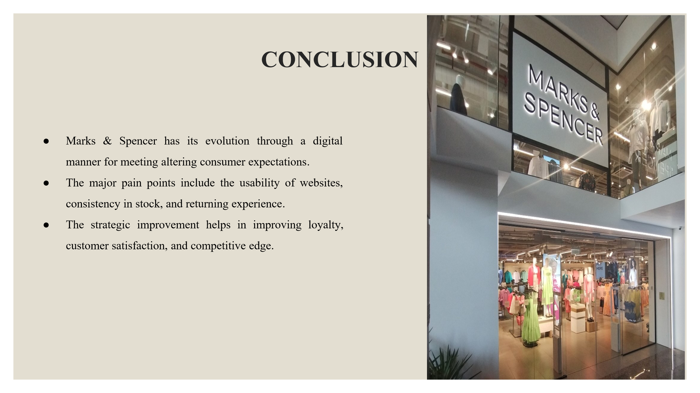

## Slide 9 - Reference List

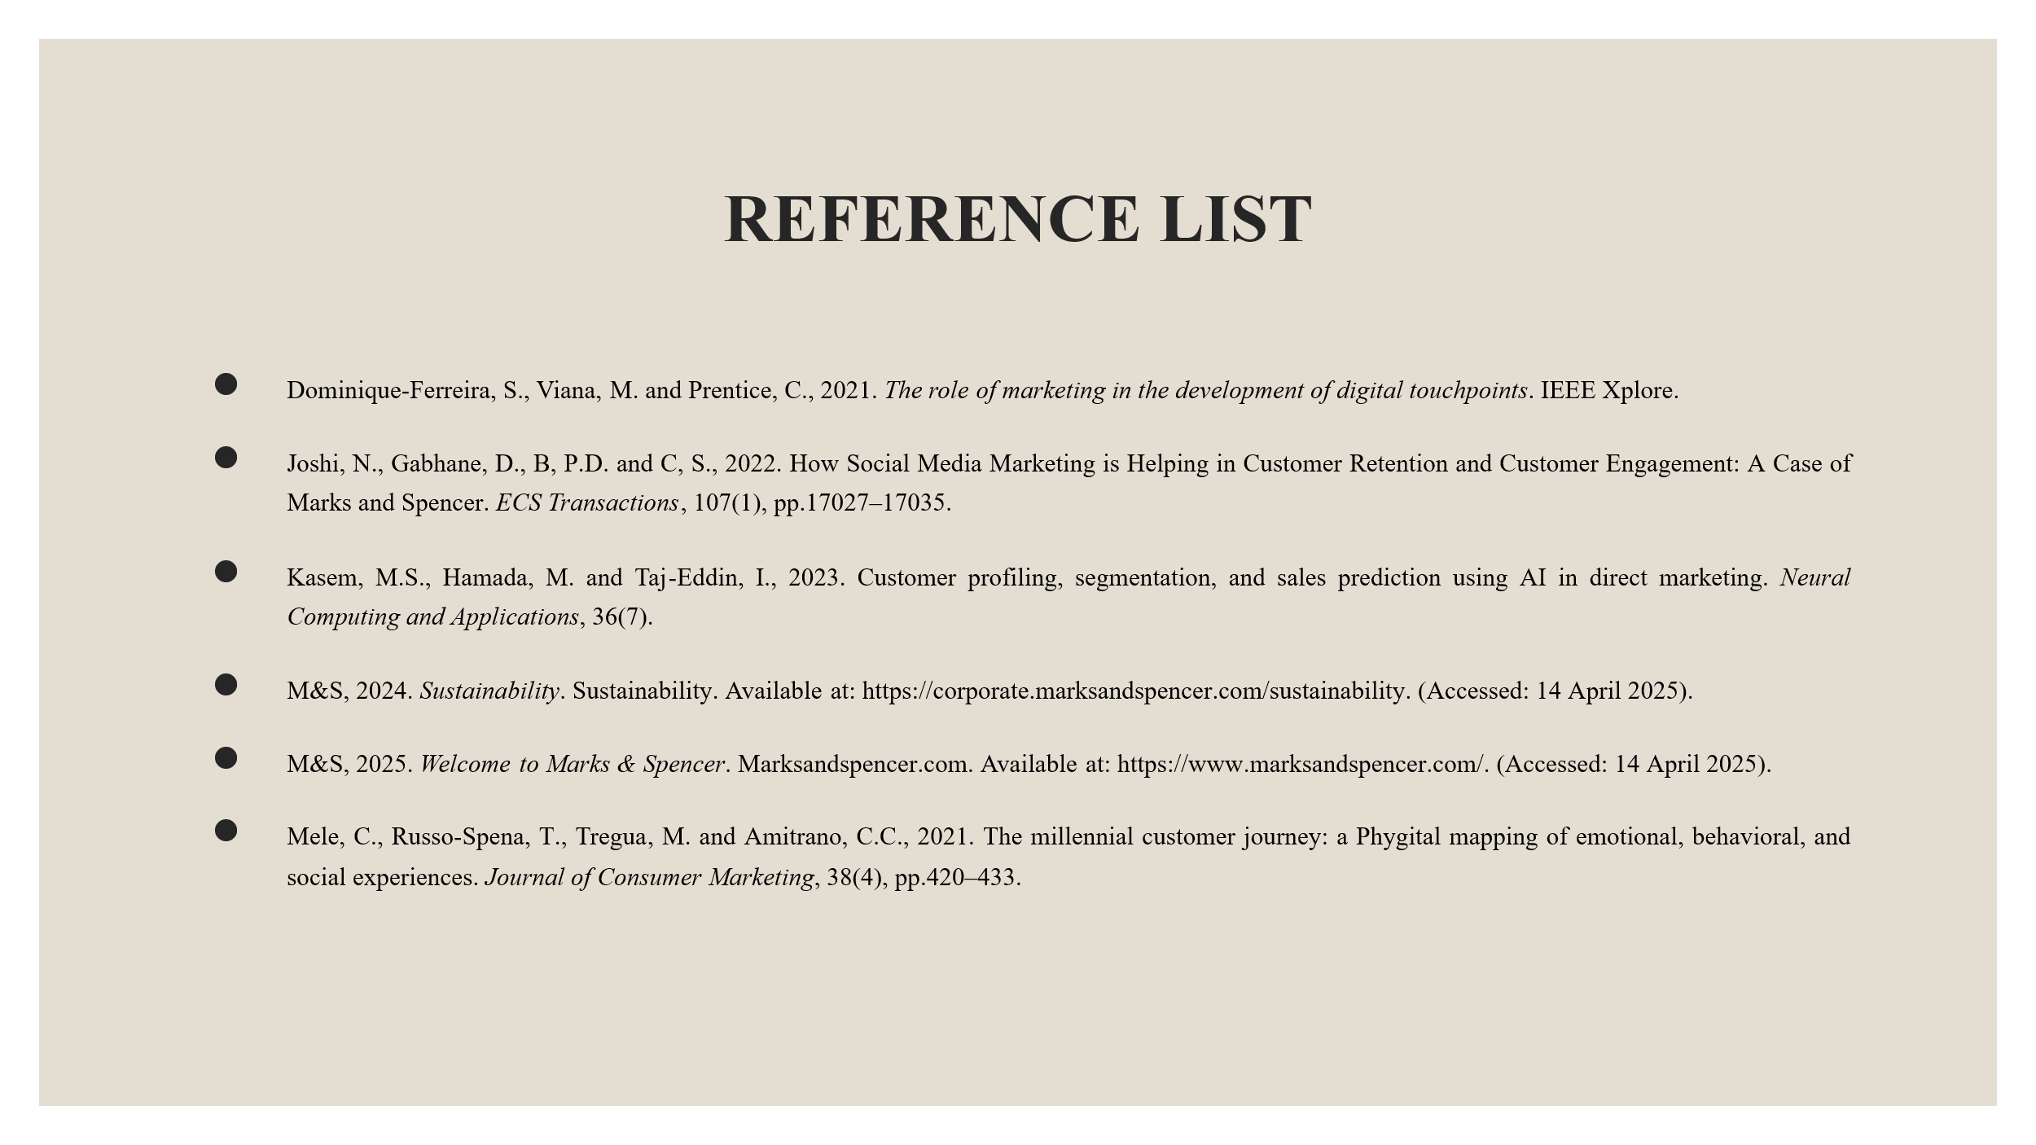

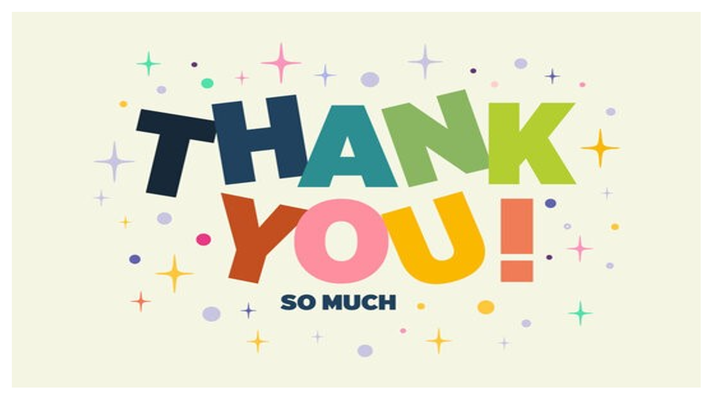

# Appendix

**Survey Questions**

***1. What is Your Age range?***

1. Below 18 Years
2. 18-25 years
3. 25-35 Years
4. 35-45 Years
5. Above 45 years

***2. How much do you agree that M&S has successfully met your personalised demands of fashion retail products which has helped you in your decision-making process?***

1. Strongly Disagree
2. Disagree
3. Neutral
4. Agree
5. Strongly Agree

***3. To what extent do you agree that the fashion retail products of M&S belong to your affordability range which gives you gain points while purchasing?***

* 1. Strongly Disagree
  2. Disagree
  3. Neutral
  4. Agree
  5. Strongly Agree

***4. To what extent do you agree that M&S is meeting the demand of Sustainable and ethically made fashion retail products which is helpful for creating customer awareness?***

* 1. Strongly Disagree
  2. Disagree
  3. Neutral
  4. Agree
  5. Strongly Agree

***5. How much do you agree that M&S needs to increase its focus on sustainable and ethically made products to improve its brand awareness?***

* 1. Strongly Disagree
  2. Disagree
  3. Neutral
  4. Agree
  5. Strongly Agree